|  |
| --- |
|  |



**23 November 2012** **The Weekly Bulletin of Rotary Club of Kathmandu Mid-Town** **Bc-23.11/012-13**

District : 3292 Web:www.rotarymidtown.org.np Club Id : 26776

**NOVEMBER IS THE ROTARY FOUNDATION MONTH**

The Future Vision Plan is designed to

• simplify Foundation programs and processes consistent with the mission,

• focus Rotarian service efforts where they will have the greatest impact by addressing priority world needs

that are relevant to Rotarians,

• offer funding options to help achieve both global and local goals,

• increase the sense of ownership at the district and club levels by transferring more decisions to the

districts,

• advance understanding of the Foundation’s work and enhance Rotary’s public image.

Monday, 19 November:

23rd Charter Night

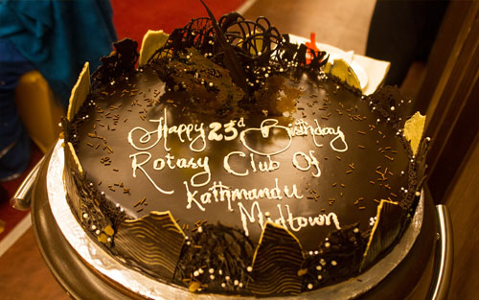

Birthday Celebration Cake, cut by none other than RI President Sakuji Tanaka

in celebration of 23rd Charter Night of Rotary Club of Kathmandu Mid-Town

***RI President Sakuji Tanaka, in Charter Night Celebration, as the Chief Guest :***

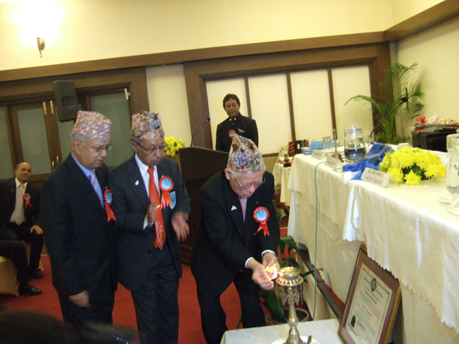

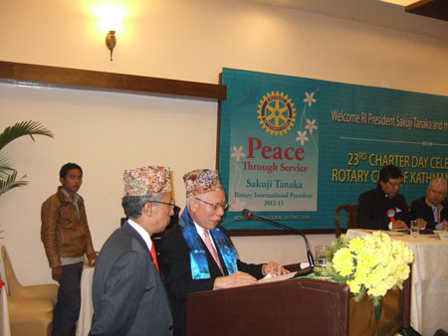

RI President Sakuji lighting the panas to begin the program RI President Sakuji addressing the audience

**23rd Charter Night:**

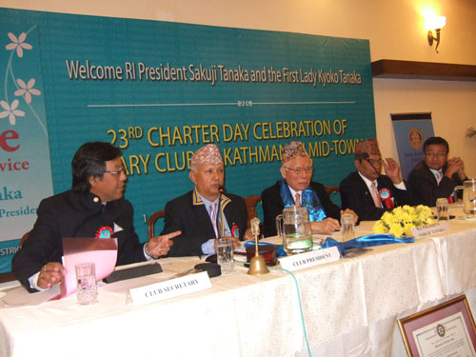

Club Meeting # 1154 in progress

RI President Sakuji Tanaka was welcomed with a presentation of a khada by Club President Gongal and the Club’s First Lady presented a bouquet of flowers to the RI First Lady Kyoko Tanaka.

**Chief Guest, RI President Sakuji Tanaka,** spoke about what it meant to be a Rotarian and spoke at length about his own personal humble beginning and his journey through life during which he received unconditional help from various people which has, in turn, inspired him to follow the path of Service Above Self throughout his life. He urged all fellow Rotarians to rededicate themselves with greater energy to help those who are less privileged than us.

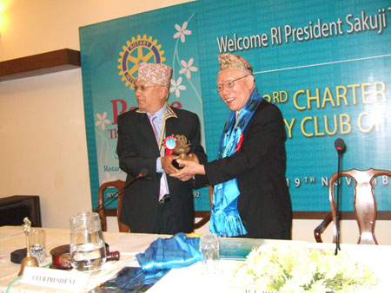

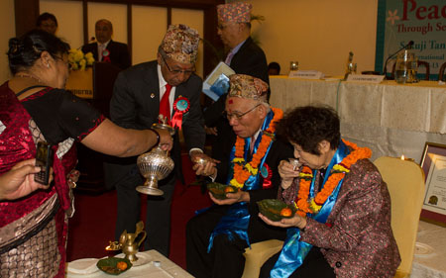

President Devendra handing over a souvenir *Sukunda* The Chief Guest and RI First Lady Kyoko being offered *khein-sagan*

to RI President Sakuji, Chief Guest of the ceremony.and *eila* by the First Lady of RI District 3292 as a mark of auspicious beginning of the celebration.

# Weekly Meetings and Programs :

|  |  |  |
| --- | --- | --- |
| Date | Program/Speaker | Program/Topics of Presentation |
| 23 Nov 2012 | Rtn. Peter Reid, RC Plymouth | ?? |
| 30 Nov 2012 | Ambassador William Bodde | Ambassador William Bodde |
| 7 Dec 2012 | Darshan Rauniyar | A Nepali-American's experience of running in US Congressional election, and some perspectives on Nepal |

Monday, 19 November: 23rd Charter Night

During the Charter Night, three international personalities have been inducted into the Club membership. PP Rtn. William anchored the entire process of Induction.

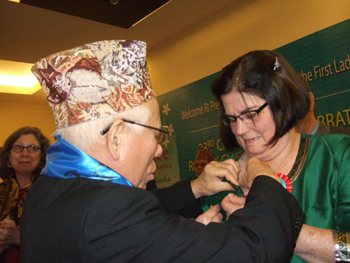

RI President Sakuji providing Rotary Pin to Catherine Sue Jenson, CEO of Scheer Memorial Hospital

Peter W Bodde

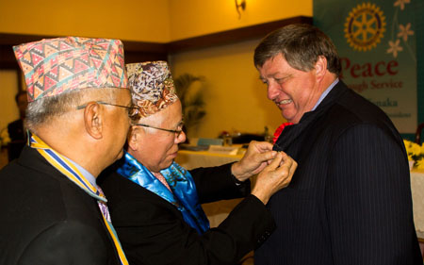

RI President Sakuji providing Rotary Pin to

US Ambassador to Nepal, Peter W Bodde

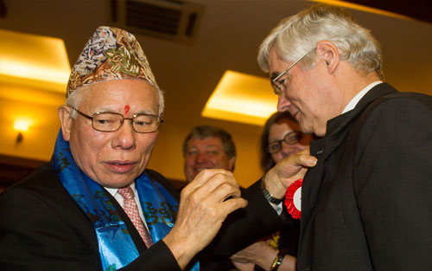

RI President Sakuji providing Rotary Pin to

German Ambassador to Nepal, Frank Meyke

District Governor Yogendra and Club President Devendra congratulated and welcomed

Rotarian Peter Bodde,

Rotarian Catherine Jenson and

Rotarian Frank Meyke

to Rotary Club of Kathmandu Mid-Town as the newest Rotarians of the Rotary World.

*Every Rotarian has a specific moment that stands out and has a special meaning.*

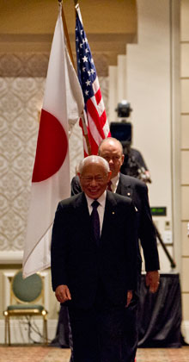

*Some people refer to this as their “Rotary Moment.” I believe it is very important to*

*share this moment with others. Facts and numbers can only go so far, but sharing a*

*personal experience can open doors and build friendships.*

**RI President Sakuji Tanaka**

On Lighter Side :

Click here ⇩



**A THOUGHT FOR THE DAY:**

**Kindness in words creates confidence.**

**Kindness in thinking creates profoundness. Kindness in giving creates love.**

*courtesy:* Rtn Dr Isabella C Bassingana Khadka

**Great Quotes:**

***What you* *don't see with your eyes, don't invent  with your mouth!***

**Answer to puzzle given in bc-16.11/012-13:**

*Clue: multiply 136 by 5 and add 5*

*The next number in the series is : 685*

NB: If you have any information/photo that may be of interest to Rotarians send them to

BC Editor: RR Shrestha email: rryesrr@gmail.com

## 23 Nov 2012 The Weekly Bulletin of Rotary Club of Kathmandu Mid-Town bc-23.11/012-13